DOCUMENT 27 — Analytics, Metrics & OKF Dashboard
Visionary Internal · v1.0 · L7 as the single source of truth (R1)

One event schema, one pipeline, one north star. Dashboards answer "is understanding
growing?" — never "are people logged in?"

1. Event schema (locked, Doc 05/08)
user_id · role · session · app · concept_id · input_type · language · board/class/exam ·
pedagogy_used · model_routed · verification_result · latency · prompt_version.
PII-scrubbed at ingest; raw text never in warehouse.

2. Metrics tree
- North star (R4): ΔP(mastered) per active learner per week.
- Activation: onboarding completion ≥80% · first "it knows me" moment ≤60s · first
verified-understand on day 1.
- Engagement: D1/D7/D30 · weekly return · daily-plan accept rate · "Why today?" taps.
- Learning quality: verified-understanding rate · pre/post concept delta · wrong-answer
recovery rate · prerequisite gap-closure rate · build completion.
- Trust: memory card edits/deletes · felt-understood survey · parent open rate >60%.
- Revenue: waitlist→active conversion · plan conversion · churn · ARPU.
- Anti-metrics: streaks and minutes-studied are secondary, never hero (Doc: mentorship
over guilt).

3. Pipeline & dashboards
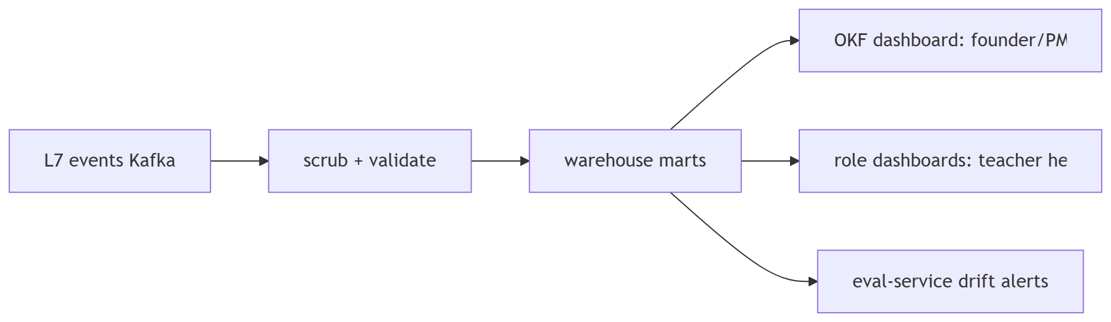
Role dashboards inherit Doc 24 RBAC; org views suppress n<5; no cross-role leakage.

OKF
KF1 100% of product interactions emit L7 (sampled audit) · KF2 north-star computed nightly
with cohort cuts · KF3 drift alert on comprehension pass-rate −5% WoW · KF4 dashboard
queries never touch raw text · KF5 every OKF has an owner + weekly review slot.

